Chapter 7 Linear motion

Chapter test answers Total marks 46

Section A

Question 1

B (2 marks)

Question 2

B. 251 ×  = 69.666 ≈ 69.7 m s–1 (2 marks)

Question 3

C. Defining east as positive:

Δv = v – u

= –6 – 7

= –13

Hence Δv = 13 m s–1 west. (2 marks)

Question 4

C. Reading from the vertical axis, at t = 60 s, x = 200 m. (2 marks)

Question 5

D. The speed is given by the gradient of the graph at this time.

= –16.666

≈ 17 m s–1 in the opposite direction (i.e. returning back towards the property). (2 marks)

Question 6

D. The farmer travelled 500 m forwards, then 500 m back to his original position, then 200 m further back: a total of 1200 m. (2 marks)

Question 7

A. Average velocity =  = *v*av = = 3.3 m s–1 back towards theproperty (2 marks)

Question 8

A.Given *u*, *v* and *t*, find *a* using *v* = *u* + *at*. (2 marks)

Section B

Question 9

a 72 km h–1 =  = 20 m s–1 (1 mark)

 (1 mark)

b Let total distance = s1 + s2 where s1 = ut + 0.5at2 and s2 = vt (1 mark)

s1 + s2= (0 + 0.5 × 4.0 × 52) + (20 × 15) (1 mark)

= 50 + 300 (1 mark)

= 350 m

c

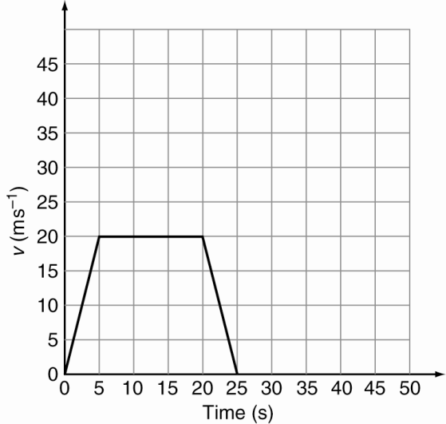

1 mark per section correctly drawn (3 marks)

Answer is consequential: gradient for first 5 s is equal to the answer to part a.

Horizontal section from t = 5 to t = 20 s is a conversion of 72 km h–1 to 20 m s–1.

d *v*av =  (1 mark)

= 

=  = 16 m s–1 (1 mark)

Answer is consequential: vav =.

Question 10

a  (1 mark)

**b** *u* = 7.50 m s–1, *a* = 0, *t* = 0.590 s, *s* = ? (1 mark)

*s* = *ut* + *at*2

= 7.50 × 0.590 = 4.43 m (1 mark)

c *u* = 7.50 m s–1, *a* = –2.50 m s–2, *v* = 0.00 m s–1, *s* = ?

use *v*2 = *u*2 + 2*as* (1 mark)

s0 = 7.502 + 2 × –2.50 × *s*

 (1 mark)

d add distances from parts b and c = 4.43 + 11.3 = 15.7 m (1 mark)

Question 11

a a = g = 9.80 m s–2 downwards (1 mark)

b Analysing the rise only: u = 20.0 m s–1, a = –9.80 m s–2, v = 0 m s–1

v = u + at (1 mark)

0 = 20 – 9.80t

–20 = –9.80t

t = 2.04 s (1 mark)

Therefore total time in the air is (2 × 2.04) = 4.08 s

c a = g = 9.80 m s–2 downwards at all stages of the flight (1 mark)

d Analysing the rise: at max height v = 0, a = –9.80 m s–2, u = 20.0 m s–1

v2 = u2 + 2as

02 = 202 + 2 × –9.80 × s (1 mark)

–400 = –19.6 s

s = 20.4 m (1 mark)

e Since there is no air resistance, the speed is the same on the way down as the way up at equivalent heights, so v = 20.0 m s–1.(1 mark)

Question 12

a Taking up as positive:

*u* = 30.0 m s–1

*s* = –40.0 m (1 mark)

*a* = –9.80 m s–2

*v*2 = *u*2 + 2as (1 mark)

= 30.02 + 2 × (–9.80) × (–40.0)

= 1684

*v* = 41.0 m s–1 (1 mark)

b *v* = *u* + *at*

*t* =

=(1 mark)

=7.24 s (1 mark)

c At the top, *u* = 0.00 m s–1.(1 mark)

*v2* = *u2 + 2as*

41.02 = 02 + 2 × –9.80× *s*

*s* = –85.8 m

The stone fell 85.8 m to the sea from the maximum height. (1 mark)